

Client Consultation Form
iUSP178 – Sports massage treatments

Centre name:
Centre number:
Learner name:
Learner number:
Date:

Client name:
Address:
Profession:
Telephone number: | Day:
Telephone number: | Evening:

Personal details:
Age group: | Under 20 ☐ | 20 – 30 ☐ | 30 – 40 ☐ | 40 – 50 ☐ | 50 – 60 ☐ | 60+ ☐
Lifestyle: | Active ☐ |  |  | Sedentary ☐
Last visit to the doctor:
GP address:
Number of children:
(If applicable)
Date of last period:
(If applicable)

Contra-indications requiring medical permission (Select if/where appropriate):
Pregnancy | ☐ | Acute trauma | ☐ | Postural deformities | ☐
Thrombosis, phlebitis, hypertension, hypotension, heart conditions) | ☐ | Open wounds | ☐ | Spastic conditions | ☐
Haemophilia | ☐ | Acute soft tissue injury | ☐ | Kidney infections | ☐
Any condition already being treated by a GP or another health professional, e.g., physiotherapist, osteopath, chiropractor, coach | ☐ | Periostitis | ☐ | Whiplash | ☐
Medical oedema | ☐ | Risk of haemorrhage | ☐ | Slipped disc | ☐
Osteoporosis | ☐ | Asthma | ☐ | Undiagnosed pain | ☐
Arthritis | ☐ | Any dysfunction of the nervous system (e.g., multiple sclerosis, Parkinson’s disease, motor neurone disease) | ☐ | When taking prescribed medication | ☐
Nervous/psychotic conditions | ☐ | Bell’s palsy | ☐ | Acute rheumatism | ☐
Epilepsy | ☐ | Trapped/pinched nerve (e.g., sciatica) | ☐ | Tumour | ☐
Recent operations | ☐ | Inflamed nerve | ☐ | Frostbite | ☐
Diabetes | ☐ | Cancer | ☐ | Bursitis | ☐
Myositis ossificans | ☐ | Mental incapacity | ☐

Written permission required by (either of which should be attached to the consultation form):
GP/specialist ☐ | Informed consent ☐

Personal information (Select if/where appropriate):
Muscular/skeletal problems: | Back |  |  | ☐ | Aches/pain |  |  |  |  |  |  | ☐ | Stiff joints |  |  |  |  |  |  |  |  | ☐ | Headaches |  | ☐
Digestive problems: | Constipation |  |  | ☐ | Bloating |  |  |  |  |  |  | ☐ | Liver/gall bladder |  |  |  |  |  |  |  |  | ☐ | Stomach |  | ☐
Circulation: | Heart |  |  | ☐ | Blood pressure |  |  |  |  |  |  | ☐ | Fluid retention |  |  |  |  |  |  |  |  | ☐ | Tired legs |  | ☐
Circulation: | Varicose veins |  |  | ☐ | Cellulite |  |  |  |  |  |  | ☐ | Kidney problems |  |  |  |  |  |  |  |  | ☐ | Cold hands and feet |  | ☐
Gynaecological: | Irregular periods |  |  | ☐ | P.M.T |  |  |  |  |  |  | ☐ | Menopause |  |  |  |  |  |  |  |  | ☐ | H.R.T |  | ☐
Gynaecological: | Pill |  |  | ☐ | Coil |  |  |  |  |  |  | ☐ | Other |  |  |  |  |  |  |  |  |  |  |  | ☐
Nervous system: | Migraine |  |  | ☐ | Tension |  |  |  |  |  |  | ☐ | Stress |  |  |  |  |  |  |  |  | ☐ | Depression |  | ☐
Immune system: | Prone to infections |  |  |  | ☐ |  | Sore throats |  |  |  |  |  |  |  | ☐ |  | Colds |  |  |  |  |  |  |  | ☐
Immune system: | Sinuses |  |  |  |  |  |  |  |  |  |  | ☐ | Chest |  |  |  |  |  |  |  |  |  |  |  | ☐
Regular antibiotic/ medication taken? | Yes |  |  | ☐ | No |  |  |  |  |  |  | ☐ | If yes, which ones?
Herbal remedies taken? | Yes |  |  | ☐ | No |  |  |  |  |  |  | ☐ | If yes, which ones?
Ability to relax: | Good |  |  |  |  | ☐ |  |  | Moderate |  |  |  |  |  |  |  |  | ☐ |  | Poor |  |  |  |  | ☐
Sleep patterns: | Good |  |  | ☐ | Poor |  |  |  |  |  |  | ☐ | Average no. of hours:
Do you see natural daylight in your workplace? | Yes |  |  |  |  |  |  |  |  |  |  | ☐ | No |  |  |  |  |  |  |  |  |  |  |  | ☐
Do you work at a computer? | Yes |  |  | ☐ | No |  |  |  |  |  |  | ☐ | If yes, how many hours?
Do you eat regular meals? | Yes |  |  |  |  |  |  |  |  |  |  | ☐ | No |  |  |  |  |  |  |  |  |  |  |  | ☐
Do you eat in a hurry? | Yes |  |  |  |  |  |  |  |  |  |  | ☐ | No |  |  |  |  |  |  |  |  |  |  |  | ☐
Do you take any food/vitamin supplements? | Yes |  |  | ☐ | No |  |  |  |  |  |  | ☐ | If so, which ones?
How many portions of each of these items does your diet contain per day? | Fresh fruit: |  |  |  | Fresh vegetables: |  |  |  |  |  |  |  | Protein and source:
 | Dairy produce: |  |  |  | Sweet things: |  |  |  |  |  |  |  | Added salt: |  |  |  |  |  |  |  |  |  | Added sugar:
How many units of these drinks do you consume per day? | Tea: |  |  |  | Coffee: |  |  |  |  |  |  |  | Fruit juice: |  |  |  |  |  |  |  |  |  | Water:
How many units of these drinks do you consume per day? | Soft drinks: |  |  |  | Others:
Do you suffer from food allergies? | Yes |  |  |  |  |  |  |  |  |  |  | ☐ | No |  |  |  |  |  |  |  |  |  |  |  | ☐
Bingeing? | Yes |  |  |  |  |  |  |  |  |  |  | ☐ | No |  |  |  |  |  |  |  |  |  |  |  | ☐
Overeating? | Yes |  |  |  |  |  |  |  |  |  |  | ☐ | No |  |  |  |  |  |  |  |  |  |  |  | ☐
Do you smoke? | Yes |  |  |  |  |  |  |  | ☐ |  | No |  |  |  |  |  |  |  | ☐ |  | How many a day?
Do you drink alcohol? | Yes |  |  |  |  |  |  |  | ☐ |  | No |  |  |  |  |  |  |  | ☐ |  | How many units a day?
Do you exercise? | None |  |  | ☐ | Occasional |  |  |  |  |  |  | ☐ | Irregular |  |  |  |  |  |  |  |  | ☐ | Regular |  | ☐
Do you exercise? | Types:
What is your skin type? | Dry | ☐ | Oily |  |  |  |  | ☐ |  | Combination |  |  |  | ☐ |  | Sensitive |  |  |  |  |  |  | ☐ | Dehydrated | ☐
Do you suffer/have you suffered from | Dermatitis |  |  | ☐ | Acne |  |  |  |  |  |  | ☐ | Eczema |  |  |  |  |  |  |  |  | ☐ | Psoriasis |  | ☐
Do you suffer/have you suffered from | Allergies |  |  | ☐ | Hay fever |  |  |  |  |  |  | ☐ | Asthma |  |  |  |  |  |  |  |  | ☐ | Skin cancer |  | ☐
Stress level 1–10 (10 being the highest): | At work |  |  |  |  |  |  |  |  |  |  | ☐ | At home |  |  |  |  |  |  |  |  |  |  |  | ☐

Physical examination (Select if/where appropriate):
Head:
Shoulders:
Back:
Pelvis:
Legs:
Feet:
Body alignment/
posture:
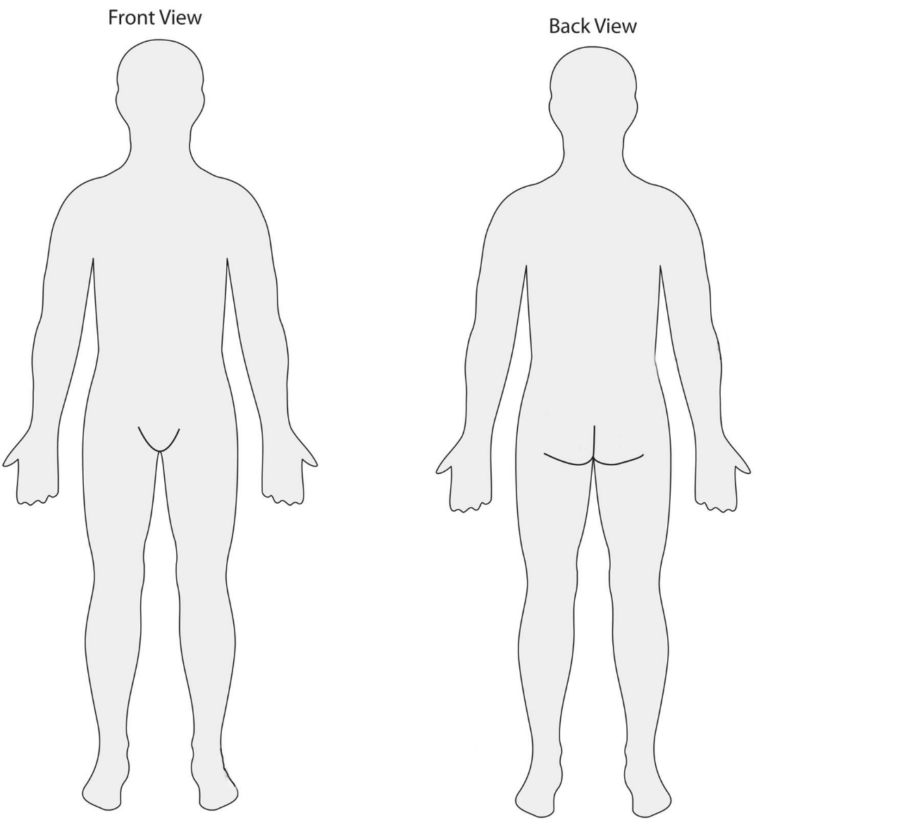

Reason for sports massage treatment plan including pre-event, post-event and maintenance:
Client feedback:

Reflect on feedback received and self-analysis of treatment:

Home care/aftercare advice:
Therapist/learner signature: ______________________________________
Client signature: ________________________________________________
Date: __________________________________________________________

